Sri Sai Anusha Gandu, Student ID: 16230560

Assignment 2

Network Architecture-I, Fall-2016

**1.** In CSMA/CD, after the fifth collision, what is the probability that a node chooses K=10? The result K=10 corresponds to a delay of how many seconds on a 10 Mbps Ethernet?

**Ans:**

Generally, NIC receives datagram from network layer and creates a frame. If NIC senses channel idle, it starts frame transmission and if it senses channel busy, it waits until channel idle and then transmits.

In case if NIC transmits entire frame without detecting another transmission, the transmission is done successfully. If it detects another transmission while transmitting, it aborts and sends jam signal. After aborting, NIC enters binary back off.

After mth collision, NIC chooses K at random from {0, 1, 2, ..., ((2m)-1)}. NIC then waits for (K*512) bit times and returns to check the channel for transmission.

Given in CSMA/CD,

mth collision = 5

This implies m = 5

K = 10

Ethernet speed = 10 Mbps

Here, ((2m)-1) = ((25)-1) = (32-1) = 31

That implies the range of K extends from 0 to 31, i.e., 32 values

The probability of choosing a value from 32 values is (1/32)

Hence, the probability of choosing K=10 is (1/32)

The waiting time computes to be K*512 = 10*512

Time delay = Waiting time/ Ethernet speed

= (10*512)/ (10*106)

= (512*10-6)

= 512 micro seconds

**Delay time = 512 micro seconds**

**2.** Consider three LANs interconnected by two routers, as shown in the diagram below.



**a.** Assign IP addresses to all the interfaces. For subnet 1 use address of the form 111.111.111.xxx; for subnet 2 use address of the form 122.222.222.xxx; and for subnet 3 use addresses of the form 133.133.133.xxx.

**Ans:**

IP addresses to all the interfaces of subnet 1

111.111.111.001, 111.111.111.002, 111.111.111.003

IP addresses to all the interfaces of subnet 2

122.222.222.001, 122.222.222.002, 122.222.222.003, 122.222.222.004

IP addresses to all the interfaces of subnet 3

133.133.133.001, 133.133.133.002, 133.133.133.003, 133.133.133.004

**b.** Assign MAC addresses to all the adapters randomly.

**Ans:**

MAC address to the adapter connecting from host A to LAN 1 is 00-00-00-00-00-00

MAC address to the adapter connecting from host B to LAN 1 is 11-11-11-11-11-11

MAC address to the adapter connecting from LAN 1 to Router 1 is 22-22-22-22-22-22

MAC address to the adapter connecting from Router 1 to LAN 2 is 33-33-33-33-33-33

MAC address to the adapter connecting from host C to LAN 2 is 44-44-44-44-44-44

MAC address to the adapter connecting from host D to LAN 2 is 55-55-55-55-55-55

MAC address to the adapter connecting from LAN 2 to Router 2 is 66-66-66-66-66-66

MAC address to the adapter connecting from Router 2 to LAN 3 is 77-77-77-77-77-77

MAC address to the adapter connecting from host E to LAN 3 is 88-88-88-88-88-88

MAC address to the adapter connecting from host F to LAN 3 is 99-99-99-99-99-99

**c.** Consider sending an IP datagram from Host A to Host F. Suppose all of the ARP tables are up to date. Enumerate all the steps as done for the single-router example.

**Ans:**

IP address of host A is 111.111.111.001

IP address of LAN 1 is 111.111.111.002

IP address of host B is 111.111.111.003

IP address of Router 1 is 122.222.222.001

IP address of host C is 122.222.222.002

IP address of LAN 2 is 122.222.222.003

IP address of host D is 122.222.222.004

IP address of Router 2 is 133.133.133.001

IP address of host E is 133.133.133.002

IP address of LAN 3 is 133.133.133.003

IP address of host F is 133.133.133.004

MAC address to the adapter connecting from host A to LAN 1 is 00-00-00-00-00-00

MAC address to the adapter connecting from host B to LAN 1 is 11-11-11-11-11-11

MAC address to the adapter connecting from LAN 1 to Router 1 is 22-22-22-22-22-22

MAC address to the adapter connecting from Router 1 to LAN 2 is 33-33-33-33-33-33

MAC address to the adapter connecting from host C to LAN 2 is 44-44-44-44-44-44

MAC address to the adapter connecting from host D to LAN 2 is 55-55-55-55-55-55

MAC address to the adapter connecting from LAN 2 to Router 2 is 66-66-66-66-66-66

MAC address to the adapter connecting from Router 2 to LAN 3 is 77-77-77-77-77-77

MAC address to the adapter connecting from host E to LAN 3 is 88-88-88-88-88-88

MAC address to the adapter connecting from host F to LAN 3 is 99-99-99-99-99-99

**STEPS:**

1. Host A creates datagram with source and destination IP address as that of host A and host F respectively.
2. Host A creates link layer frame with source and destination MAC address as that of host A and router respectively.
3. Frame is received from host A to router where the datagram is removed and passed up to IP.
4. The router forwards datagram with source and destination IP address as that of host A and host F respectively.
5. The router creates link layer frame with source and destination MAC address as that of router and host F respectively.
6. The datagram is received at host F and the information is decrypted from the packet and sent to the link layer.

**d.** Repeat (c), now assuming that the ARP table in the sending host is empty (and the other tables are up to date).

**Ans:**

If the ARP table of the sending host is empty, then the sending host i.e., host A has to determine the MAC address of the first router interface.

This process is done as mentioned below.

1. Initially, host A sends an ARP request/query packet within the broadcast Ethernet frame.
2. The router receives the query packet and sends the response packet to host A. The ARP response packet is carried by the Ethernet frame with the destination address as the MAC address of the router i.e., 22-22-22-22-22-22.

Now that the ARP table of host A is updated, the IP datagram is sent in the process mentioned below.

**STEPS:**

1. Host A creates datagram with source and destination IP address as that of host A and host F respectively.
2. Host A creates link layer frame with source and destination MAC address as that of host A and router respectively.
3. Frame is received from host A to router where the datagram is removed and passed up to IP.
4. The router forwards datagram with source and destination IP address as that of host A and host F respectively.
5. The router creates link layer frame with source and destination MAC address as that of router and host F respectively.
6. The datagram is received at host F and the information is decrypted from the packet and sent to the link layer.

**3.** Suppose a CSMA/CD network is running 100 Mbps over a 1-km cable with no repeaters. The signal speed in the cable is 400,000km/sec.

**a.** Compute the following:

i. End-to-end propagation delay.

ii. Worst-case (i.e., the longest) collision detection time.

iii. Minimum frame size. (Hint: the frame size should be big enough to be transmitted during the full worst case collision detection time)

**Ans:**

Given

Cable length = 1 km

Bandwidth = 100 Mbps = 100*106 bps

Signal speed = 400,000 km/sec

i. End-to-end propagation delay = Cable length/ Signal speed

= 1/ 400,000

= 2.5 micro seconds

**End-to-end propagation delay = 2.5 micro seconds**

ii. Worst case collision detection time = Round trip propagation time

= 2*(End-to-end propagation time)

= 2*(2.5 micro seconds)

= 5 micro seconds

**Worst case collision detection time = 5 micro seconds**

iii. Minimum frame size = 2*(End-to-end propagation time)*(Bandwidth)

= 2*(2.5 micro seconds)*(100*106 bps)

= 500 bits

**Minimum frame size = 500 bits**

**b.** Suppose we increase the bandwidth from 100 Mbps to 1 Gbps, how does it affect the above three values?

**Ans:**

Changing the bandwidth from 100 Mbps to 1 Gbps doesn’t affect the end-to-end propagation time and the worst case collision detection time. But it does have its affect on the minimum frame size.

Minimum frame size when the bandwidth is changed from 100 Mbps to 1 Gbps

= 2*(End-to-end propagation time)*(Bandwidth)

= 2*(2.5 micro seconds)*(109 bps)

= 5000 bits

**Minimum frame size with bandwidth changed from 100 Mbps to 1 Gbps = 5000 bits**

**4.** What are the Physical and IP addresses of the host?

**Ans:**

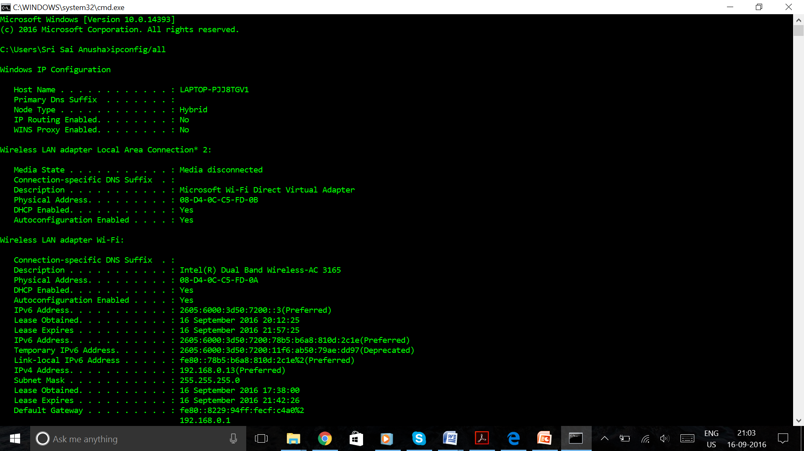

The physical address (MAC address) of the host is given by 08-D4-0C-C5-FD-0A

**PHYSICAL ADDRESS = 08-D4-0C-C5-FD-0A**

The IP address of the host is given by 192.168.0.13

**IP ADDRESS = 192.168.0.13**

**5.** How many bits are for the subnet mask? What is the subnet (not subnet mask) of the host?

**Ans:**

Generally the number of bits in subnet mask is 32.

Here, the subnet mask is 255.255.255.0

The number of bits in subnet mask here is 24.

To get the subnet of the host, we need to perform AND operation between IP address and subnet mask in binary form.

IP address = 192.168.0.13

Subnet mask = 255.255.255.0

IP address = 11000000. 10101000. 00000000. 00001101

Subnet mask = 11111111. 11111111. 11111111. 00000000

Subnet = 11000000. 10101000. 00000000. 00000000

= 192.168.0.0

**Subnet of the host = 192.168.0.0**

**6.** Try ‘ARP’ command in order to

**a.** Show the current ARP table of an interface of your host.

**Ans:**

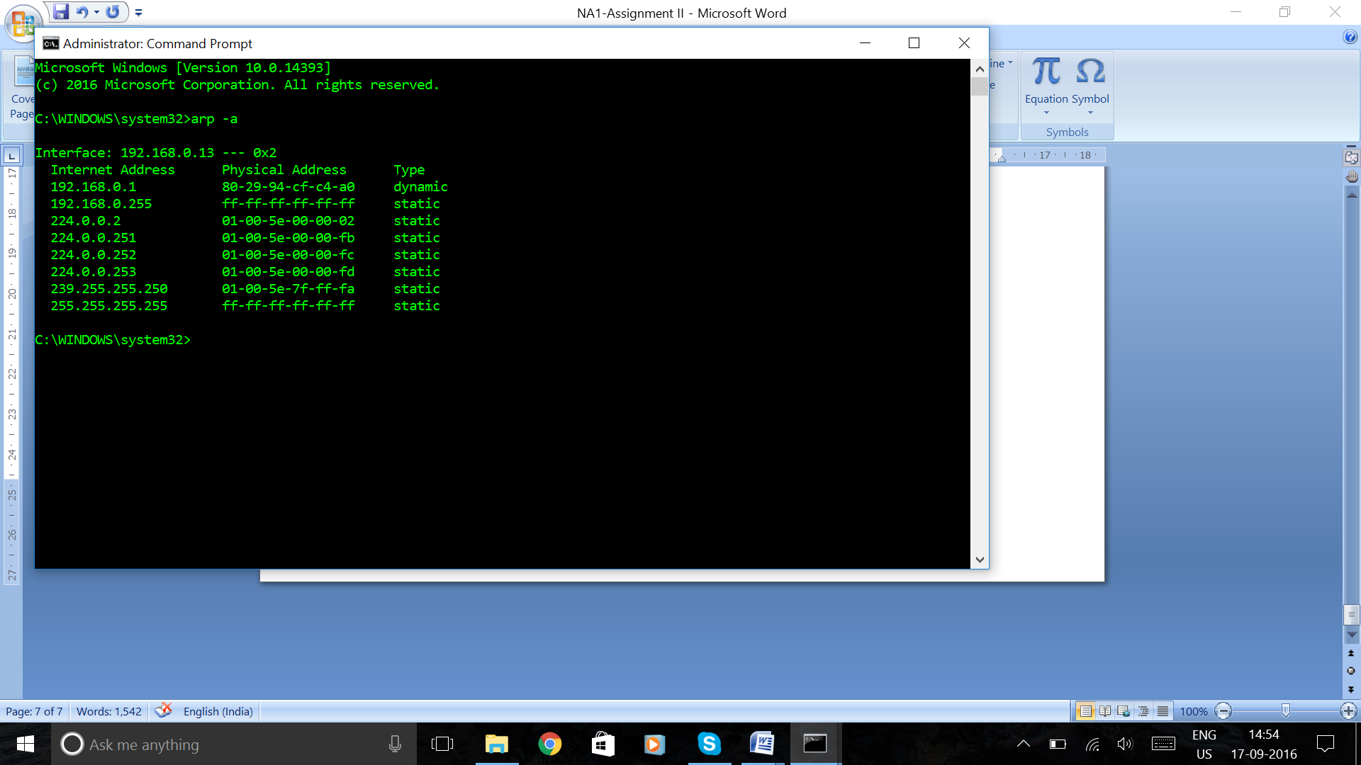

**b.** Delete all the current entries of the ARP table of an interface of your host.

**Ans:**

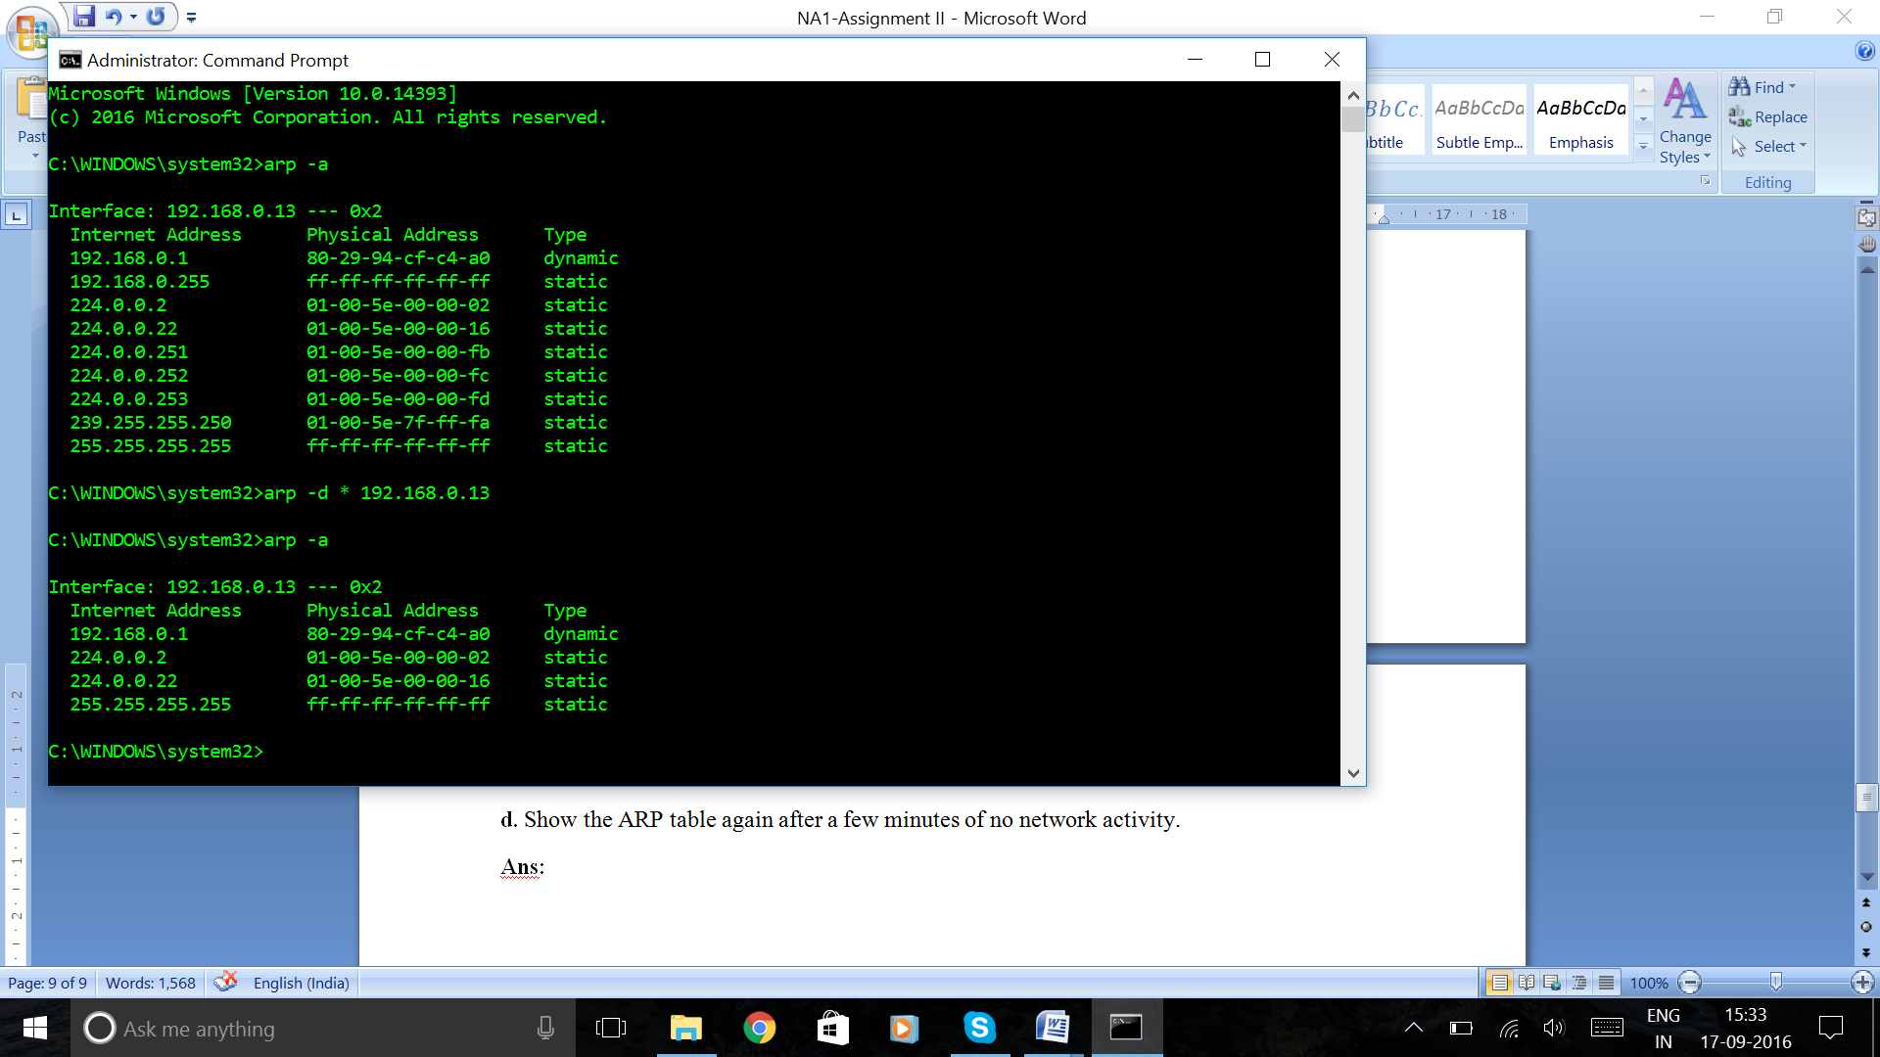

**c.** Show the ARP table again after a web browsing.

**Ans:**

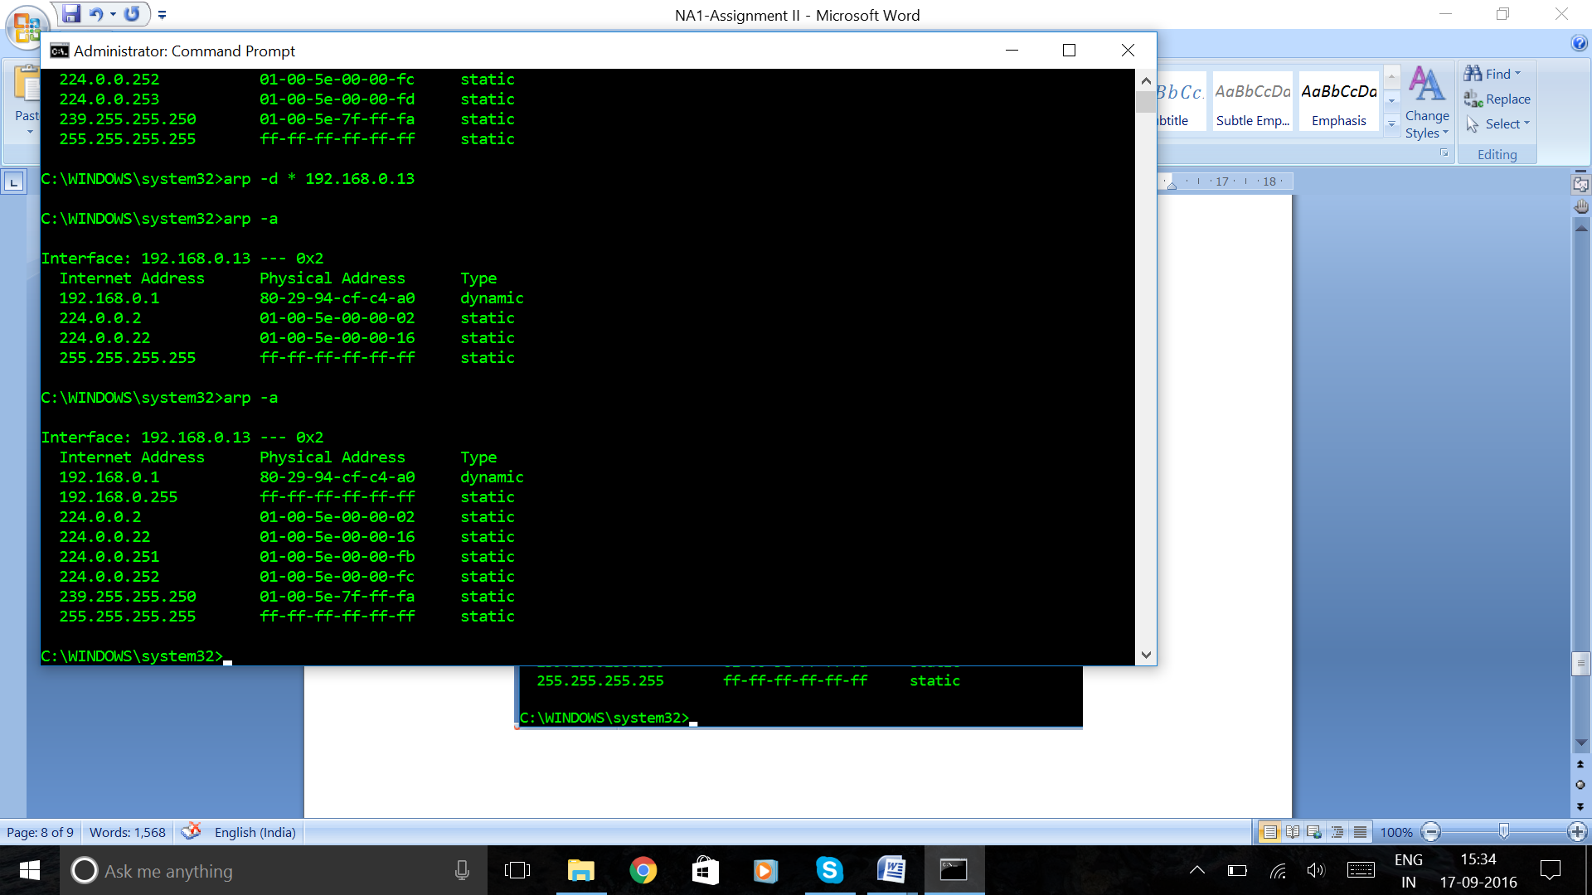

**d.** Show the ARP table again after a few minutes of no network activity.

**Ans:**

